NAME: Bagas Satrio Wicaksono

Link to Github: https://github.com/Bagassatwi/PBO/tree/master/week%201%20-%20OOP%20Introduction/assignment

Question Test

Explain the difference between object and class!
Object: Sequence of program which consists of state and behavior.
Class: Blueprint or prototype from object.

State your reason why gear and brand can be classified as attribute for Bike object!
Because Gear and brand are universal and exists in all of bikes.

State one of OOP better point than procedural programming!
Because it avoids repetitive code

Is it allowed to define two attributes in one line code such “public String name, address;”?
Yes, in this case, both name and address will have a String datatype.

In RoadBike class, state your reason why brand, speed, and gear attributes are not written again in this class!
Because RoadBike inherits those attributes from the Bike class.

Assignment

Follow these instructions to make your practical assignment is performed systematically:
- Take 4 photographs of objects around you, 2 objects must be implementation of inheritance concept, example: refrigerator, chair, living room table, desk! As we know that living room table and desk are inherited by table class

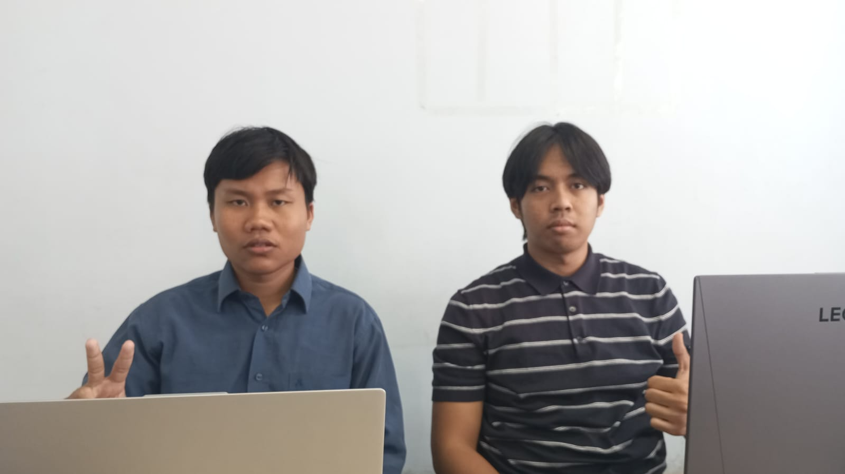

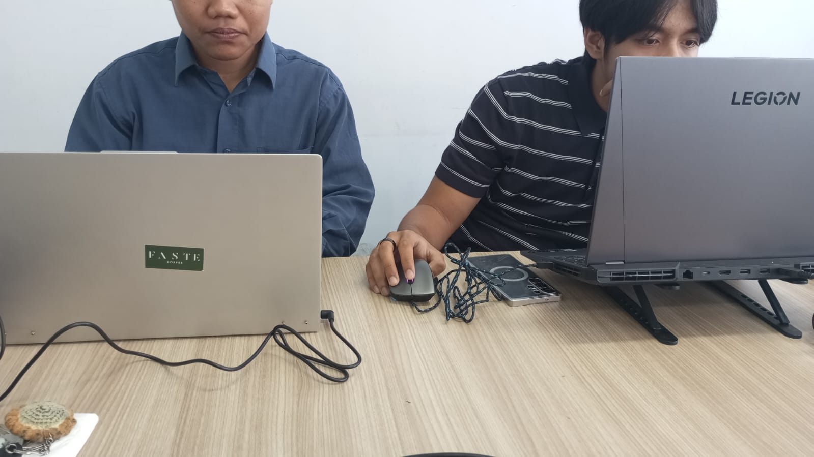

- Observe those objects to define the attribute and method!
- Convert those objects into four classes in Java programming!
- Add one additional class as a class which inherits its attribute and method to living room table class and desk class!
- Add two attributes for each class!
- Add three methods for each class including a method for showing the information!
- Add one class named Demo for main class!
- Instance an object for each class!
- Apply each method for each object in main class!
- The example which is mentioned in point 1.a should not be included in your task!

Demo Code
Below is the AssignmentDemo.java used to instantiate objects and exercise each class' methods (also included in the assignment package):

package assignment;

public class AssignmentDemo {
public static void main(String[] args) {
KalimantanPeople Atha = new KalimantanPeople("Atha", 170, 69, 20);
BatuPeople Rayyan = new BatuPeople("Rayyan", 167, 67, 19);

Atha.setPetSize(3);
Rayyan.setGardenSize(25);

GamingLaptop lenovoLegion = new GamingLaptop("Lenovo", 15.6F, "3840 x 2160", "Mechanical");
WorkLaptop lenovoIdeapad = new WorkLaptop("Lenovo", 12.4F, "1920 x 1080", "Chiclet");

lenovoLegion.setFanSpeed(4200);
lenovoIdeapad.setSDCardReadingSpeed(95);

System.out.println("--- Humans ---");
Atha.printInfo();
Atha.pet();
Atha.fly();

System.out.println();
Rayyan.printInfo();
Rayyan.harvest();
Rayyan.plant();

System.out.println();
System.out.println("--- Laptops ---");
lenovoLegion.printInfo();
lenovoLegion.switchGPU();
lenovoLegion.turnOnRGB();

System.out.println();
lenovoIdeapad.printInfo();
lenovoIdeapad.insertSDCard();
lenovoIdeapad.takeOutSDCard();
}
}

